Project Design Phase-II
Technology Stack (Architecture & Stack)

Date | 01 November 2025
Team ID | NM2025TMID00449
Project Name | Laptop Request Catalog Item
Maximum Marks | 4 Marks

Technical Architecture Overview

All components are hosted on the ServiceNow SaaS platform, integrated via ServiceNow-native tools and APIs. The solution uses proprietary ServiceNow modules for digital catalog item creation, process automation, security, and data management.

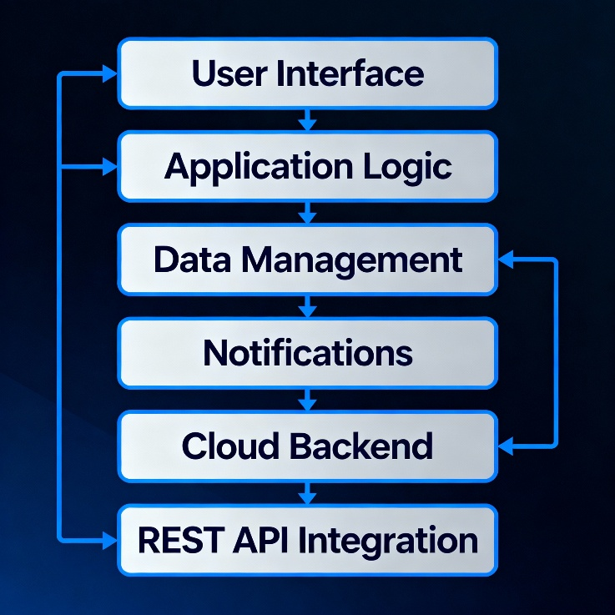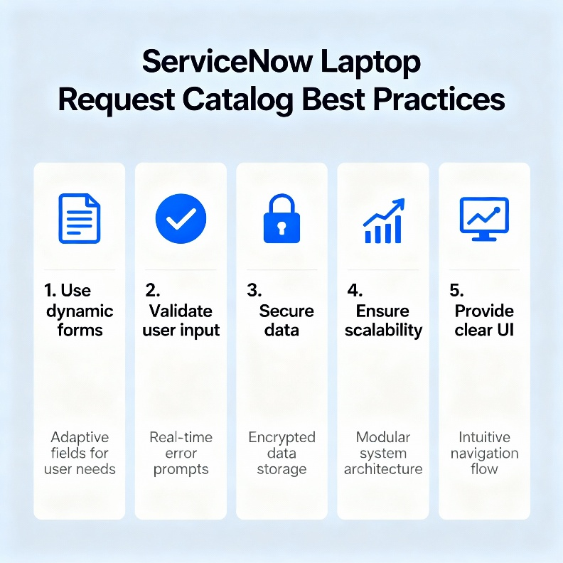

Components & Technologies

S.No | Component | Description | Technology
1 | User Interface | Employees and admins interact via ServiceNow web interface | ServiceNow Web UI
2 | Application Logic | Automates dynamic field logic, validates requests, stores data | Flow Designer, Client Scripts, Server Scripts
3 | Data Management | Tracks requests, user info, and assets | ServiceNow CMDB, Incident Tables
4 | Notifications | Sends request and fulfillment updates | ServiceNow Notifications
5 | Security | Role-based access, ACLs, data protections | ServiceNow ACLs, Scoped Apps
6 | Cloud Backend | SaaS infrastructure for scalable, reliable hosting | ServiceNow Cloud (Managed, Load-balanced)
7 | External Integration | (Optional) HRMS or identity system for user verification | REST API (ServiceNow)

Application Characteristics

S.No | Characteristic | Description | Technology
1 | Security | Access control enforced for all catalog actions | ACLs, Scoped Apps
2 | Scalability | SaaS-based, handles hundreds of requests | Cloud Architecture
3 | Availability | 24/7 uptime with load balanced instances | ServiceNow Hosting
4 | Performance | Fast UI response, optimized, asynchronous flows | GlideRecord, Background Scripts

